**Digital Imaging Systems**

**Project 02 – Option 0**

**Name- Manthan Sunil Talegaonkar**

**Unity Id- mstalega**

Some of the function used in the code may not get executed in Jupyter Notebook as it has been coded on **Google Colab.**

Please Access the **Google Colab Link below** to access the code.

Another File with code and Images is provided names as **mstalega_document2.pdf.**

**Google Colab Link -** [**https://colab.research.google.com/drive/1tGOaAqCfQ2nPmkbdyLTo4b2H7tWewo5l?usp=sharing**](https://colab.research.google.com/drive/1tGOaAqCfQ2nPmkbdyLTo4b2H7tWewo5l?usp=sharing)

**Note - Code is not included** in this document. Only the **Result Images** have been included.

**Q1.**

1. Padding For Gray Scale (wolves.png)

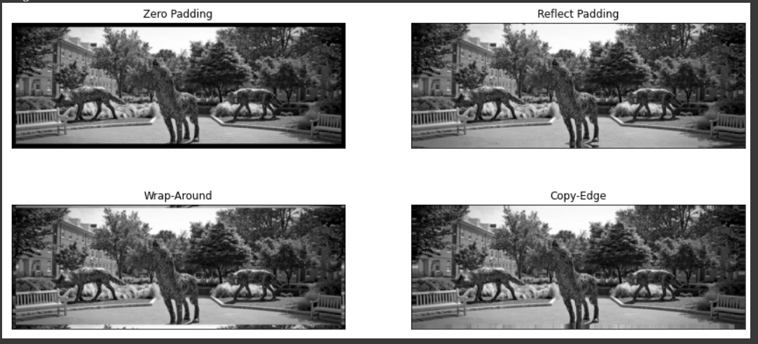

Padding for Color Image with **Box** Kernel (lena.png)

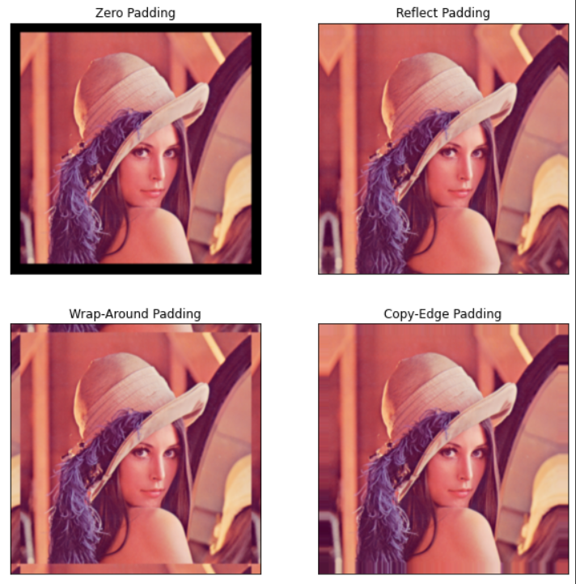

Convolution for Black and White (wolves.png) with all kernels and Zero Padding. Using Matplotlib.

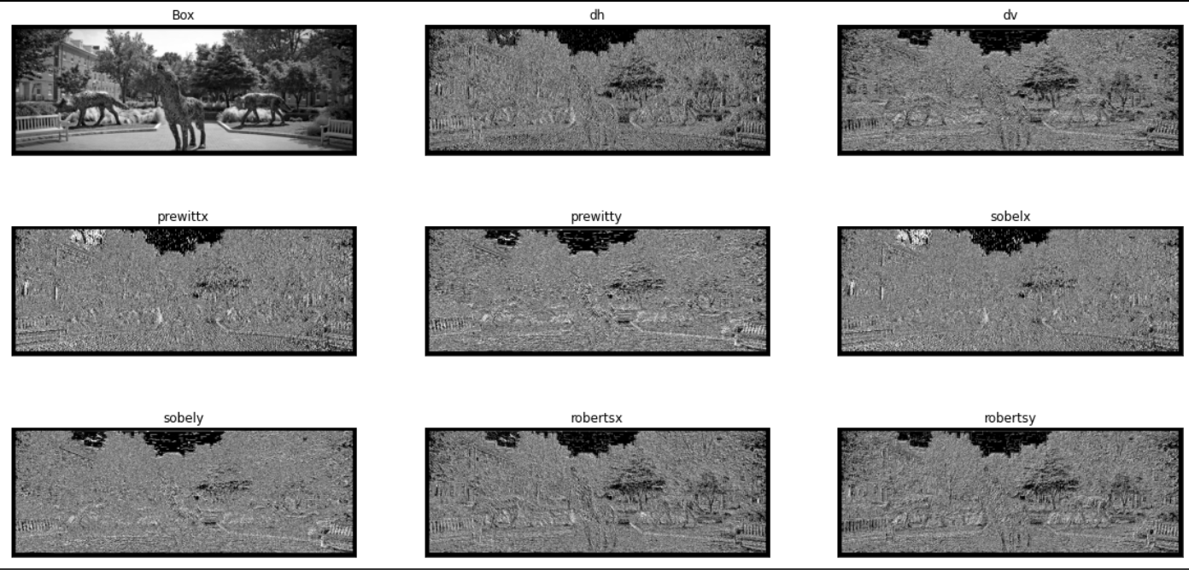

Convolution for Color (lena.png) with all Kernels and Reflect Padding. Using Matplotlib

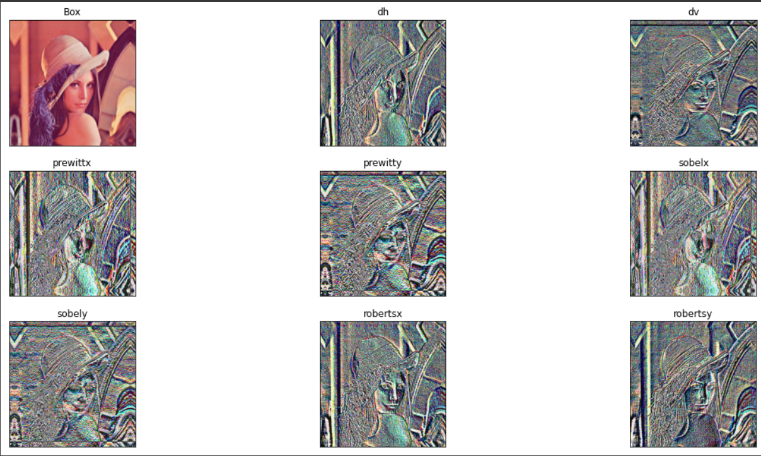

1 b.

Using Zero Padding and Prewitt Y Kernel.

Before Convolution



After Convolution



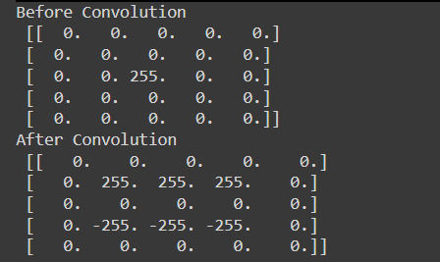

We clearly see that Convolution is being Performed as the Values are getting changed according to Prewitt Y Kernel for the given Image.

**Q2.**

a.

Output for 2d- DFT function for **wolves.png**

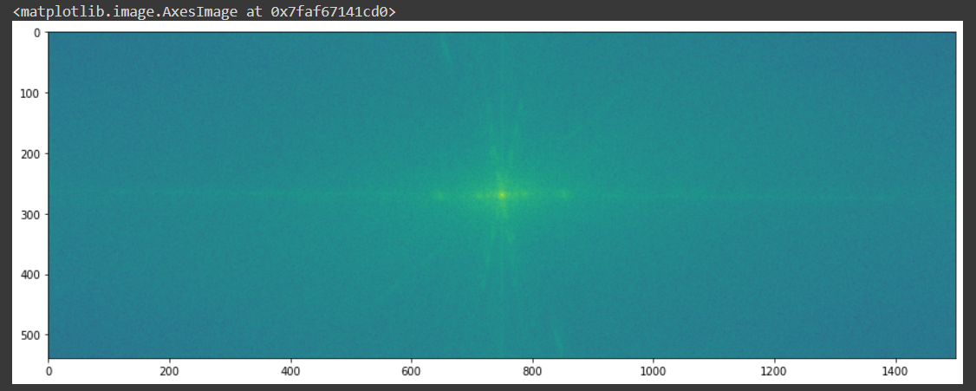

Output for 2d -DFT function for **lena.png**

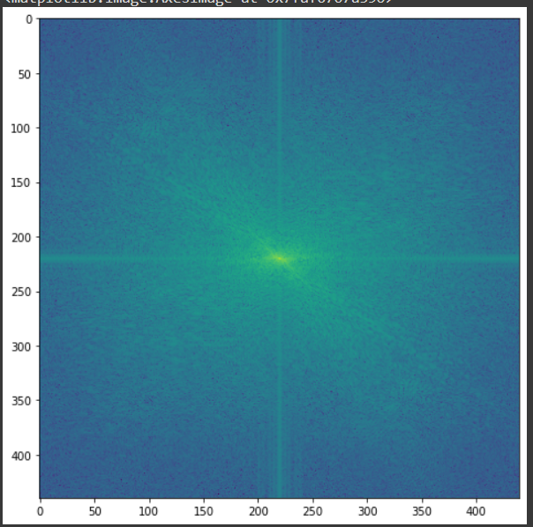

b.

